The impact of Basel III implementation on bank lending in South Africa

Xolani Sibande[1] and Alistair Milne[2]

This version: December, 2023

**Abstract**

This study investigates the impact of the Basel III capital requirement on the supply of bank credit in South Africa. The literature offers greatly varying estimates of the impact of bank capital requirements on loan supply. Using a specification closely modelled on the related study of Peru by Fang et al. (2020), we report panel regressions using monthly balance sheet data for the biggest four banks in South Africa distinguishing three different categories of bank lending for both household and corporate borrowers; and reporting a complementary local projection estimates to capture dynamic impacts. We find little evidence that the introduction of higher capital requirements under Basel III has reduced the supply of bank credit in South Africa. We surmise this is mainly due to the large banks being well-capitalised and operating with large buffers of capital over and above regulatory minimum requirements.

**Keywords:** Bank capital, Bank regulation, Credit

**JEL Codes**: G01, G18, G28, G32, G38

# 1 Introduction

This paper investigates the impact on bank credit supply of the higher regulatory capital requirements of the implementation of the Basel III in South Africa between 2013 and 2019. Following earlier literature, the investigation reported here focuses on the impact of changes in minimum required levels of bank capital and of changes in the ‘buffers’ of capital and liquidity above these minima. The principal data employed is monthly balance sheet data, for the four largest South African banks, which together account for more than 80% of bank assets in South Africa. This data is both higher frequency (monthly) and more detailed (distinguishing several categories of both corporate and household credit) than the data used in other related empirical studies.

This focus on a small set of large banks has some advantages. The business models of these banks are similar. They all use sophisticated tools of capital management and take a substantial proportion of funding as wholesale deposits from non-financial corporates and non-bank financial institutions which impacts on their Basel III net stable funding ratios. It also though has the disadvantage of providing only a relative small data set, over a period in which banks faced no substantial problems of balance sheet capital management.

Section 2 is our literature review. This summarises the findings of similar empirical studies of the impact of changes in capital and capital requirements on bank credit supply, most of which are for developed countries. It states several grounds for caution about the interpretation of the reported coefficients in existing studies. Section 3 summarise the key developments in South African banking over our sample period. These include: the recovery of the banking sector from the impact of the global financial crisis 2009-2011 and an associated rebuilding of capital buffers, and the phasing in of Basel III from 2013 to 2019. Section 4 describes our data set and sets out our empirical specification. Section 5 presents our main results. Section 6 concludes. There are three Appendices: one providing a theoretical framework for understanding the impact of bank capital on the supply lending; a second details of data sources and a third some alternative estimation results.

# 2 Existing empirical literature

This section provides an overview of the empirical literature on the impact of bank capital, bank regulatory requirements and of bank capital buffers (the difference between capital and capital requirements) on the supply of bank credit.[3] The estimation attempted in this empirical literature is extremely challenging. One reason for this, a prediction of the theory of bank capital as summarised in Appendix A, is that the relationships involved are highly non-linear. For well capitalised banks with substantial capital buffers, when there is very low probability of breaching minimum required capital requirements over the period for which credit is extended, then changes in the level of bank capital or of required regulatory requirements have a relatively small impact on overall cost of funding and credit supply. As capital buffers fall the probability of a breach of minimum capital requirements increases non-monotonically as buffers fall towards zero, at first only slightly and then much more substantially. The impact of a change in capital requirements on credit supply increases non-monotonically along with the increase in probability of breach.

A second reason is the confounding impact of both credit demand and of banks own risk and capital management. For example, bank capital may fall and bank capital requirements may be increased at the same time as the bank’s own borrowers are reducing demand for credit; and additionally the bank itself may be increasing its assessments of borrower’s risk of default. For both these reasons banks may reduce lending to that borrower independently of any associated change in capital requirements or capital buffers. Furthermore, it is also necessary to take account of the dynamics of bank capital management and the consequent endogeneity of changes in bank capital and bank capital buffers. Specifically (this is the case for the changes in Basel III minimum capital requirements in South Africa investigated in the present paper) changes in capital requirement can be announced well before they are implemented, giving banks the opportunity to increase capital buffers and both smooth and minimise the portfolio impact of changed capital requirements when they are implemented.

Despite these empirical challenges, the literature does reveal that bank capital and also changing bank capital requirements can have a substantial impact on bank credit supply when banks are capital constrained. An early branch of this literature exploits differences in capitalisation of bank holding companies and bank subsidiaries/ branches (to correct for the endogeneity of bank capital, resulting from the impact of credit demand on bank earnings and hence capital) to quantify the impact of a fall of capitalisation on the supply of bank credit. Peek and Rosengren (1997) find that in the period 1989H1 to 1995:H2 a 1% reduction in the Japanese bank parent risk-based capital ratio, due to the Japanese financial crisis, reduces the six-monthly growth rate of total lending by Japanese bank branches in the US by approximately 1.9% of total branch assets and C&I lending by 0.8% of total assets.

Houston, James and Marcus (1997) similarly find that loan growth in US bank subsidiaries increases by 2% following a 1% addition to holding company capital, but there is no statistically significant impact from an addition to subsidiary capital, a supply effected resulting from the internal allocation of bank capital. Calomiris and Wilson, (2004) review the data on large declines in book and market value of equity capital of large New York City banks during the great depression of the 1930s and infer, from substantial deposit withdrawals and increased credit spread on remaining uninsured deposits, that this resulted a substantial reduction in their supply of credit. Several other papers find lower rates of credit expansion for banks close the regulatory minimum level of capital (see, Hancock and Wilcox, 1994; Berger and Udell, 1994; Gambacorta and Mistrulli, 2004; Nier and Zicchino, 2005; Van den Heuvel, 2008; Berrospide and Edge, 2010).

Another branch of the empirical literature investigates the impact of bank specific changes in regulatory capital requirements on bank credit growth. Much of this work has been undertaken using UK data, where bank regulators have set frequently adjusted individual bank ‘trigger ratios’ for minimum risk-weighted capital, higher than the Basel international minima, breach of which prompts additional supervisory intervention. Francis and Osborne (2012) investigate the impact of changes in buffer capital, finding that a decline of 1% in risk weighted capital relative to an estimated target reduces risk-weighted assets by 7% (but the impact is relatively small when the result of a recent change in capital requirements and has no statistically significant impact on unweighted lending or total assets). Aiyar *et al.* (2014) and Aiyar, Calomiris and Wieladek (2016) exploit the same UK data individual changes in bank capital requirements to quantify the direct impact of a change in the UK “trigger ratios”, the bank specific capital ratios set higher than the Basel minima.

Aiyar *et al.* (2014) investigate the impact of changes in the UK bank trigger ratio on credit growth, using quarterly data for the period 1998-2007, employing the current and three lags of changes in the trigger ratio (i.e. a similar specification to that used in this paper). They report that “an increase in the capital requirement ratio of 100 basis points, induces on average a cumulative fall in loan growth of 5.7 and 6 percentage points.” These estimates include a bank specific credit demand proxy, based on weighted average employment growth in 14 industrial sectors and bank lending shares, but this proxy is not statistically significant. Aiyar, Calomiris and Wieladek (2016a) extend the specification to include changes in interest rates, reporting a similar but slightly smaller loan responses to changes in the trigger ratio. Aiyar, Calomiris and Wieladek (2014b) focus on impact on international lending by UK banks, allowing a stronger control for credit demand based on country specific time effects, reporting cumulative fall of international lending of between 5.5%.

A concern with these estimates of the impact of a change in the UK trigger ratio on bank credit supply is that these are typically increased when supervisors are concerned about increased bank risk exposure. The reported estimates may reflect the response of the bank to this increased risk exposure rather than the impact of higher capital requirements. This criticism does not apply to the estimates of Jiménez *et al.* (2017), exploiting the dynamic forward looking loan loss provisioning in Spain combined with firm-bank level data to identify credit supply impacts. Their identification follows the approach pioneered by Khwaja and Mian (2008), exploiting firm-bank level data on borrowing by firms with multiple (two or more) bank credit relationships. Where a shock has a varying bank impact, then the credit supply impact of the shock can be estimated as a ‘difference in difference’. For Jiménez *et al.* (2017) this is an estimate of the impact of the differences between banks in changes in capital requirement (arising from the Spanish regime of forward-looking dynamic provisioning introduced in 200Q3) on the difference in growth of credit by banks whenever they lend to the same firm. Specifically they focus on ‘bad times’, the reduction in the required capital for anticipated loan loss provisions from 33% to 10% in 2008Q4 and then from 10% to 0% in 2009:Q4. They find that the resulting countercyclical reductions in capital requirements in these ‘bad times’, helped sustain credit growth (a 1 percentage point increase in capital buffers increasing credit to firms by 9 percentage points).

De Jonghe et. al. (2020) use a similar approach to identification in their examination the impact on corporate lending in Belgium of discretionary supervisory adjustments to additional discretionary capital requirements (over and above the Basel II minima), between April 2011 and November 2014. These adjustments were made periodically on a bank by bank basis, in much the same way as in the changes in UK trigger ratios exploited by Aiyar et. al. (2014). Belgian credit registry data for firms borrowing from multiple banks allow them to compare quarterly credit growth from a bank impacted by a change in required capital to credit growth with credit growth by other banks to the same borrower. They find that an increase in required regulatory capital of 1.5% results I 0.19% lower credit growth i.e. an impact that is an order of magnitude smaller than reported by Aiyar et al. (2014) and Jiminez et al. (2017).

Fraisse, Lé and Thesmar (2020), using the same ‘difference in difference’ approach to identification, look at the impact of borrower specific capital weights on corporate credit extended by the six largest French banking groups and their subsidiaries under the Basel II internal models-based determination of risk weighted assets for the years 2008-2011. They find that a 1% increase in the risk capital weighting of a firm reduces lending to that firm by 1.4%-2.1% (at the intensive margin i.e. conditional on lending still taking place) and reducing overall credit by 2.3%-4.5% (allowing also for the extensive margin, i.e. a decision to completely cease lending). While the identification strategy is similar, this is otherwise a very different approach that of Jiminez et. al. (2008). They ‘saturate’ their panel estimation with bank-year dummies, thus consciously excluding the impact of aggregate capital requirements or aggregate capital buffers on the supply of bank credit. They focus instead of how differences in banks internal risk weights for individual firms impact on the supply of bank credit to those firms. This tells us that internal capital allocation has an impact on relative credit supply to different firms but is not informative about the impact of overall capital requirements or capital buffers on bank credit.

There are very few studies for emerging markets investigating the impact of bank capital requirements on credit supply in emerging markets. One is Fang *et al.* (2020) model bank loan growth, using a specification similar to Aiyar, Calomiris and Wieladek (2014, 2016a), including a similar demand proxy, and using quarterly bank data 2005- 2016 for Peru. Their data includes an increase in minimum required capital from 9.`1% to 10% of risk weighted assets announced in July 2008 and implemented in three stages, in July of the following three years: in 2009 (to 9.5%), 2010 (to 9.8%) and in 2011 (to 10.0%); together with the introduction of a regime of additional bank specific capital buffers again implemented in July of each year over the period 2012-2016. They report that a one percentage increase in the capital requirement – during the second phase of additional bank specific capital buffers - reduces lending by 4-6 percent in the same quarter; however strikingly this impact lasts only one quarter, by the following quarter the impact is no longer statistically significant. Their specification addresses the concern with Aiyar et. al. (2014) about changing bank risk as a confounding variable, correlated with changes in discretionary adjustment to bank capital, by using only the relatively large changes to required capital in July of the years 2012-2016 (‘jumps’) and ignoring small changes (‘wiggles’) in other months. We will use the same approach in our own estimation; but acknowledging a problem not considered by Fang et al. (2020) about seasonal variation in the distribution of bank credit across banks.

Aiyar et al. (2014), Fang *et al.* (2020) control for credit demand using a measure based on sector-specific lending weights as a proportion of sector output. Pillay and Makrelov (2023) construct the same measure in the South African context. Both Fang *et al.* (2020) and Pillay and Makrelov (2023) find that this measure was not significant. As described below we use a different approach to control for demand based on bank specific loan product lending rates.

# 3 Developments in South African Banking

## 3.1 Economic background.

During the first fifteen years of democracy, from 1993 to 2008, real South African GDP grew at more than 3.5% per year;[4] supported by the post-apartheid reintegration into the global economy, trade liberalisation, a diversification of economic activity and a policy regime emphasising both fiscal and monetary discipline.[5] Public debt was reduced from 48% of GDP in 1995 to 28% in 2007.[6] Inflation fell from 9.1% in 1993-95 to 3.2% in 2004-2005, with inflation targeting formally introduced in February 2000.

South Africa was also financially stable with a profitable and well capitalised albeit concentrated banking sector. GDP growth slowed temporarily on occasion, triggered by capital outflows and pressure on the exchange rate, both in 1998 during the aftermath of the Asian financial crisis and in 2001 during the post-dot.com global economic slowdown. There were some small bank failures during the latter episode, but neither episode had any systemic financial impact and demand and growth recovered relatively quickly.

## 3.2 Banking sector: structure and regulation

There are 34 active licensed banks in South Africa;[7] but of these five domestically controlled commercial banks together account for around 90% of banking sector assets.[8] South Africa also has a sophisticated non-bank financial services industry with large life- insurance, pension and unit-trust sectors. The ratio of bank assets to GDP is 112% while total financial sector assets amount to 298% of GDP.

South Africa has a well-developed regime of financial regulation that has evolved in line with international financial standards. A solvency regime, similar to the EU Solvency II, for the life insurance sector was introduced in 2011, along with a program of regulatory reform including a shift to a ‘twin peaks’ organisational structure legislated in 2017, with the SARB responsible for prudential and systemic risk while the Financial Sector Conduct Authority for market conduct and consumer protection.

This prudential regulation and South Africa’s well-capitalised banking sector has prevented the emergence any systemic financial crisis. There is concern about the reliance of the main South African banks on wholesale deposit funding, from non-financial corporates and non-bank financial institutions, which has created some challenges in meeting the Basel III ‘net stable funding requirements’ NSFR ratio. None of the episodes of financial stress, though, in the past three decade have triggered systemic financial problems. These episodes are the exchange rate depreciations of 1998 and 2001, the latter associated with several small bank failures, the impact of the 2008 GFC, the failure of a small lender Africa Bank in 2014 or the 2020 pandemic. Non-performing loans have risen substantially, as a share of bank loans, both in the early 2000’s and following the 2008 GFC and the 2020 pandemic to reach around 5% of gross loans outstanding.[9] But the banking sector has remained profitable with return on assets close to 1.5% and return on equity around 15% over the years 2008-2020.

**Figure 1: Bank assets**

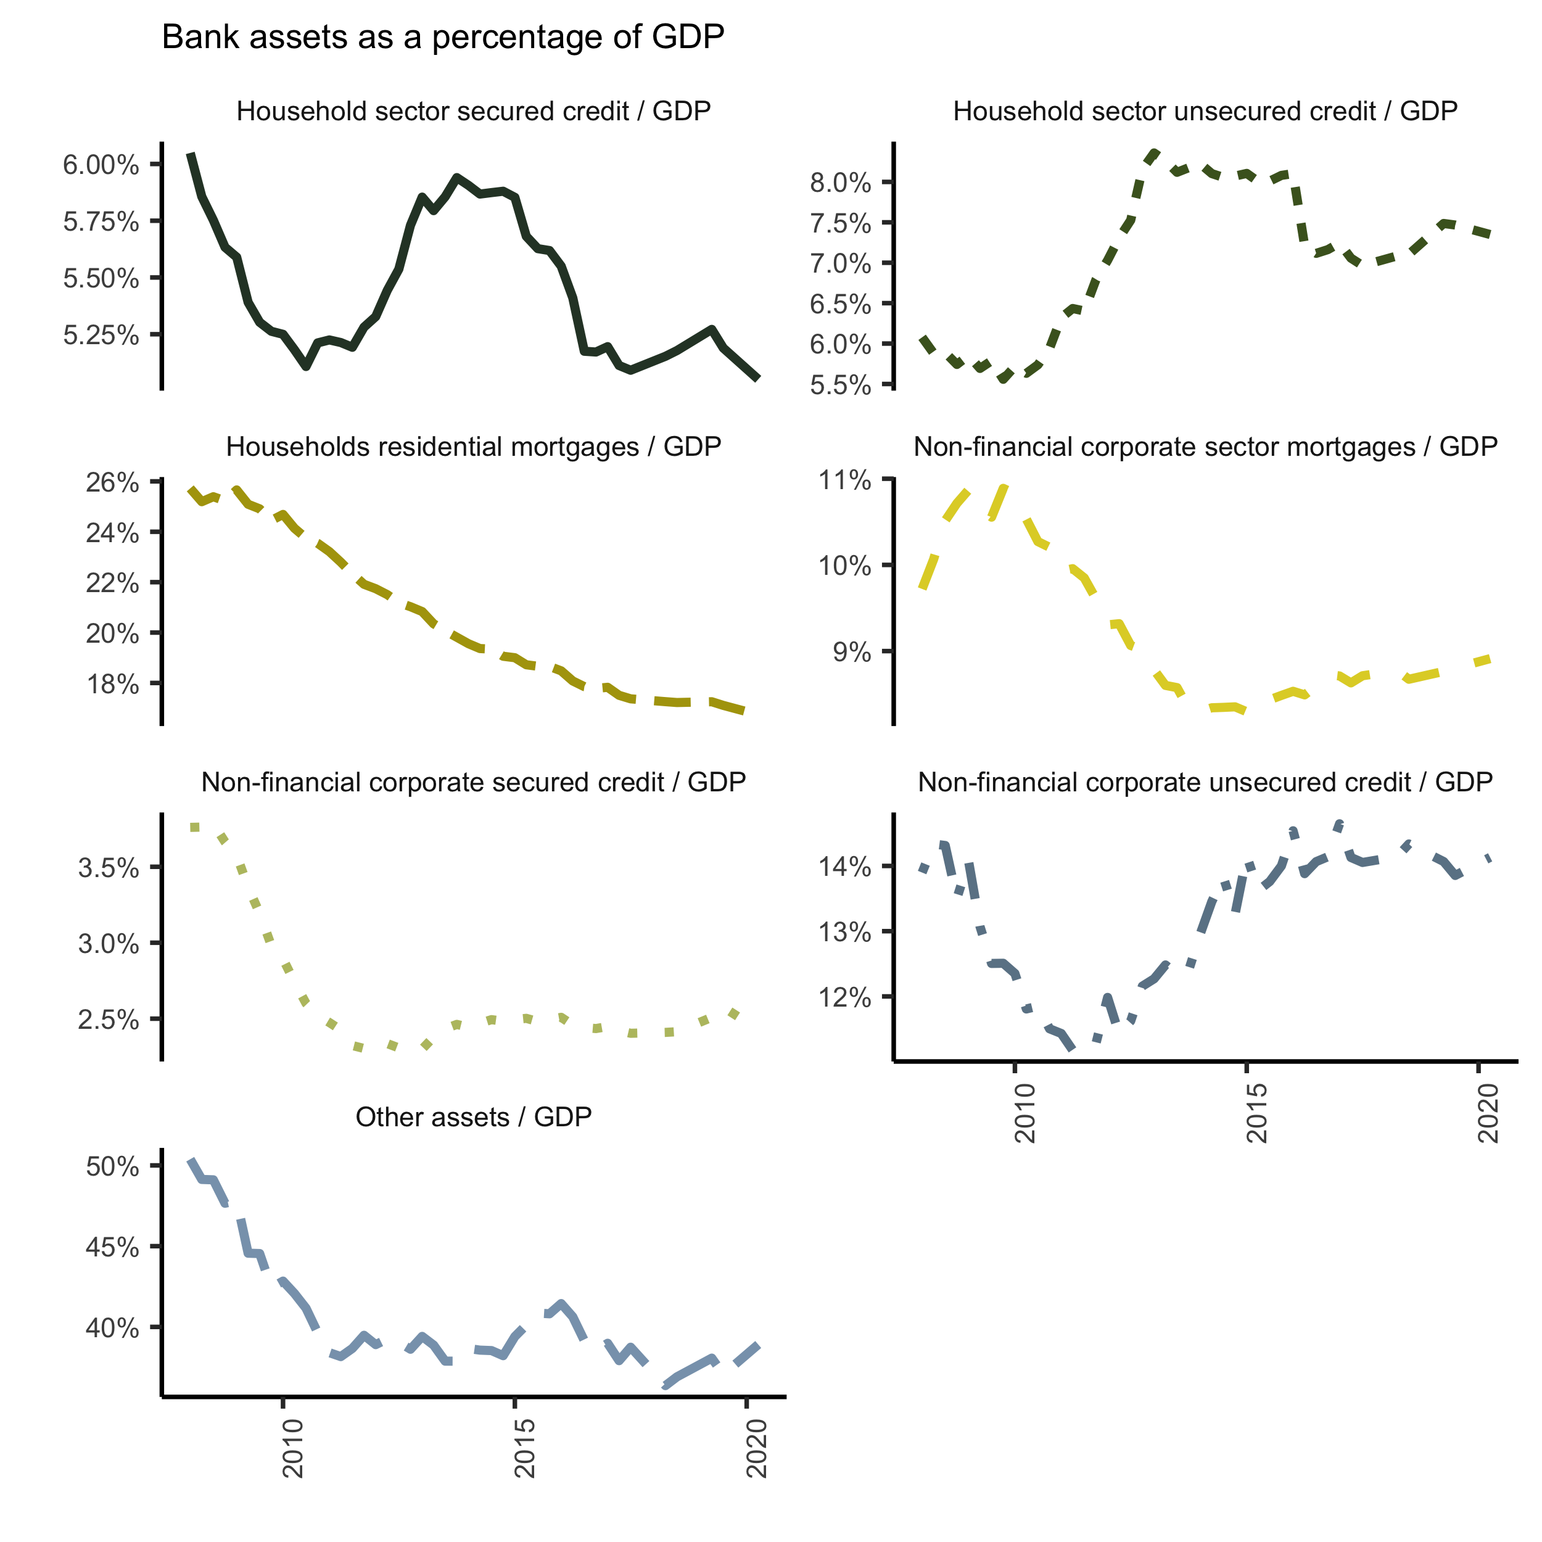

Source: South African Reserve Bank (2022)

While banks have remained profitable, the growth of private sector credit in South Africa slowed substantially after the GFC (see Figure 1). The share of banking sector household mortgage lending to GDP fell from 26% in 2008 to 18% in 2020. Other forms of household credit, secured and unsecured, grew by around 2% of GDP between 2008 and 2013 but have since fallen back. Credit to non-financial corporations has also fallen somewhat since 2008.

In general, the path of the credit categories is well in line with the increase in bank lending in the second half of the 2000s, and the subsequent slow down because of tighter monetary policy and the introduction of Basel II in South Africa. However, post 2013 some categories of lending such as unsecured credit for households due to the post financial crisis policy easing. Moderation can be observed after this period due to structurally slower economic growth in the country and more recently the COVID crisis.

## 3.3 Capital requirements reforms in South Africa

South Africa implemented the Basel III bank capital regulation framework between 2013 and 2019. The full framework covers three forms of equity capital: core equity; additional Tier 1 capital that absorbs losses on a ‘going concern’ basis; and the total capital (Tier 1 plus Tier 2) that that protects depositors and taxpayers when a bank fails. The focus of our work is on total capital.

Table 1 shows the various elements of the total capital requirements introduced in South Africa. This starts with the Basel III minimum of 8 per cent of each bank’s risk weighted assets. To this are added: the Pillar 2 elements based on supervisory risk assessment (Pillar 2A is the systemic risk requirement, Pillar 2B is the bank-specific individual capital requirement) and three additional buffers that are available for use as macroprudential policy instruments.[10]

**Table 1: Basel III total capital (Tier 1 + Tier 2) requirements in South Africa**

|  | Percent |
| --- | --- |
| Basel III minima | 8 |
| South African minima | 8 |
| Pillar 2A | 0.5 to 2 |
| South Africa base minima | 8+Pillar 2A |
| Pillar 2B (ICR) | no specific range |
| Prudential minima | 8+Pillar2A+ICR |
| Systemically important buffer | 0.5 to 2.5 |
| Capital conservation buffer | 0 to 2.5 |
| Countercyclical buffer | 0 to 2.5 |

Source: South African Reserve Bank (2013)

The authorities stipulated the phase-in period shown in Table 2. The conservation buffer, countercyclical buffers, and the capital charge for domestic systemically important banks were only introduced in 2016. At the same time, the systemic risk capital requirement (Pillar 2A) was reduced to avoid double counting. In the main, the authorities persisted with the phase-in schedule will only minor deviations regarding the range-bound measures.

**Table 2: Basel III implementation (%)**

|  | 2013 | 2014 | 2015 | 2016 | 2017 | 2018 | 2019 |
| --- | --- | --- | --- | --- | --- | --- | --- |
| Basel III minima | 8 | 8 | 8 | 8 | 8 | 8 | 8 |
| Pillar 2A for Total Capital | 1.5 | 2 | 2 | 1.8 | 1.5 | 1.3 | 1 |
| Minimum Total Capital Plus 2A | 9.5 | 10 | 10 | 9.8 | 9.5 | 9.3 | 9 |
| Phasing in of specified charge for systemically important banks (as % of Pillar 2A) |  |  |  | 25 | 50 | 75 | 100 |
| Capital conservation buffer |  |  |  | 0.625 | 1.25 | 1.875 | 2.5 |
| Countercyclical buffer |  |  |  | 0.625 | 1.25 | 1.875 | 2.5 |

Source: South African Reserve Bank (2013)

South African banks hold a discretionary buffer above the regulated minimum requirements. The buffer of bank capital over minimum regulatory requirements for the sector has varied, rising from around 2% in 2008 to 6% in 2013, but with the introduction of the higher Basel III requirements has since fallen, fluctuating in range of 2-4% since 2015 (see Figure 2).

**Figure 2: Capital requirements**

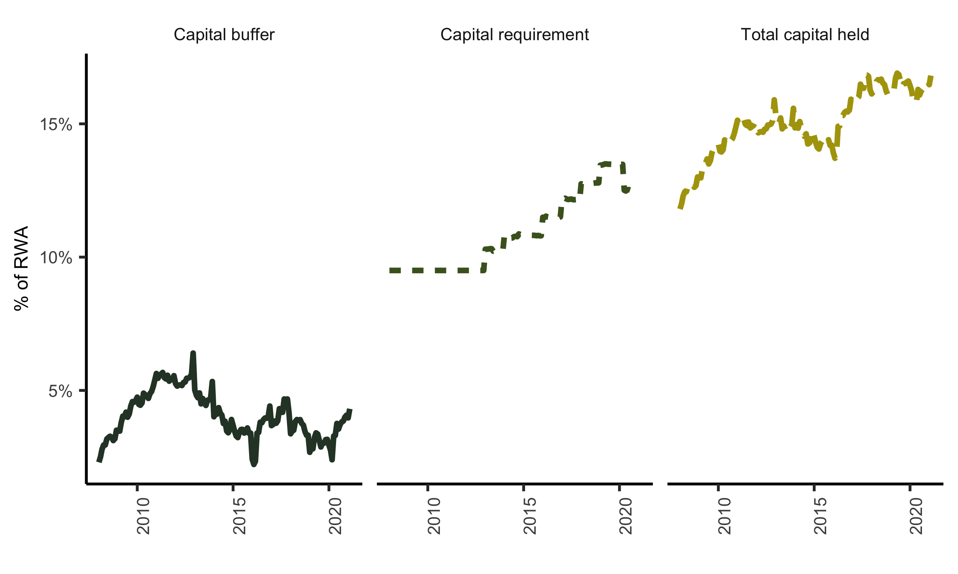

Source: South African Reserve Bank (2022). Note: RWA is risk weighted assets

# 4 Data and Methodology

We collected data on the four major South African banks; Absa Bank, Standard Bank, First National Bank, and Nedbank. Together these constitute over 80% of the banking sector assets. Our main data sources were the monthly Banks Act (BA) statutory disclosures collected by the South African Reserve Bank (SARB). The Banks Act obliges the SARB to collect and publish bank balance sheets and other data to understand the country’s banking activity scale. We mainly utilised the BA900s (bank balance sheet returns) and the BA930s (bank product lending rates). The Basel III capital requirements (BA700s) data was collected from the South African Prudential Authority (PA) - the financial sector regulator. From the same source, we also collected the controls data. Tables B.1 and B.2 in Appendix B summarise the specific data. Most bank-level data is confidential data held by the SARB; however, the BA900 bank-level balance sheet data is public.

These data have some distinctive features, making them promising for investigating the determinants of bank credit supply when compared to what is available for other countries. First, unusually, the South African data provides granular public domain monthly balance sheet reports with a detailed breakdown of bank assets and liabilities for individual banks. Second confidential granular bank by bank matching loan category data on product lending rates. This pricing data offers the potential of employing a new approach from that used in the existing literature to identify credit supply effects.

Our focus is on the effect of higher capital requirements on lending to non-financial household and corporate borrowers. The BA900s distinguishes twenty-four lending categories to households and non-financial corporations. Many of these categories are closely related, therefore, some aggregation is appropriate. The aggregation of this data, combining related granular lending categories into broader categories, is explained in Appendix B. This results in three lending categories for both households and for non-financial corporations: unsecured credit, secured credit, and mortgages. These six categories form the foundation of our analysis.

Table 3 provides the definitions of and summary statistics for our dependent and independent variables. In the literature section, we explained the challenges in separating the bank lending effect of specific Basel III actions from banks’ normal risk and portfolio adjustment actions. To address this identification problem, we follow Fang *et al.* (2020), using a dummy variable interaction to distinguish between changes due to Basel III, in the case of South Africa the jumps in capital requirements introduce in January of the years 2014 to 2019 in the phased introduction of the Basel III higher minimum capital requirements (Table 2), and small fluctuations resulting from changes in RWA (see Figure 2). or minimum capital requirement is an interactive dummy that isolates the specific Basel III changes to the regulatory capital buffer requirements as explained in Section 3.3. We also distinguish between the excess capital that the banks choose to hold above the minimum capital buffer requirement ().

To control for demand for credit we utilise the lending rates corresponding to our six broad lending categories (see Figure B.1 in Appendix B). We define as the change in the interest rate margin (lending rate less the SARB policy rate) as a measure of lending demand. The intuition is that an increase in the lending rate relative to the policy rate is indicative of an increase in demand and so including this in the specification we can control for changes in bank specific loan demand correlated with changes in capital requirements. Therefore, this approach requires that we only utilise flexible rates which can adjust with the policy rate. However, it must be noted that despite the use of controls the interest rate margin may still not only reflect demand aspects. For example, other idiosyncratic factors such as a shock in bank funding conditions can have an impact. However, we contend that in general the lending rates are informative enough for our study.

After adjusting the data in Table 3 for outliers (winsorizing the data with a 1% threshold), we estimate the following equation, for the six lending categories, using the ordinary least squares estimator:

is the log difference of lending between months and for bank . is the bank level change in the minimum capital requirement between months and , and similarly is the change in the bank-level capital buffer between months and . Based on Table 1, this definition of implies that we estimate the bank specific changes to the capital requirement since all other capital requirements are common amongst the banks. is the lending demand proxy represented by the bank-level change in the interest rate margin between months and . is a bank level controls set at month . Our choice of controls flows from Fang *et al.* (2020), which are at a bank-level return on assets, return on equity (profitability), and high liquid assets held (liquidity). The fixed effects () estimate other unobserved differences in bank characteristics. To account for other factors, such as changes in the macroeconomic environment, we employ time-fixed effects (). In summary, we estimate this specification for each of the lending category with a panel of four banks between 2013 and 2019. As shown in Section 5 this amounts to six regressions per estimation, that is, three regressions for households and non-financial corporations (unsecured credit, secured credit and mortgages), respectively.

**Table 3: Variable Definitions and Summary Statistics**

| Variable | Definition | Category | Median | SD | Min | Max | Obs |
| --- | --- | --- | --- | --- | --- | --- | --- |
|  | Month on month change in the natural logarithm of nominal loans. | Household secured credit | 0.005 | 0.008 | -0.029 | 0.025 | 363 |
|  |  | Household unsecured credit | 0.005 | 0.010 | -0.032 | 0.035 | 363 |
|  |  | Household mortgage credit | 0.003 | 0.003 | -0.005 | 0.011 | 363 |
|  |  | Non-financial corporations secured credit | 0.004 | 0.013 | -0.042 | 0.045 | 363 |
|  |  | Non-financial corporations unsecured credit | 0.005 | 0.011 | -0.025 | 0.037 | 363 |
|  |  | Non-financial corporations mortgage credit | 0.003 | 0.029 | -0.066 | 0.092 | 363 |
|  | Month on month changes in the minimum capital requirement (Basel III). |  | 0.000 | 0.002 | -0.002 | 0.009 | 363 |
|  | Monthly difference between the total capital buffer requirement and the minimum capital requirement. |  | -0.001 | 0.004 | -0.012 | 0.018 | 363 |
|  | Monthly change in the interest rate margin (category credit rate less the policy rate or repo). | Household secured credit | 0.000 | 0.127 | -0.430 | 0.380 | 363 |
|  |  | Household unsecured credit | -0.000 | 0.129 | -0.473 | 0.560 | 363 |
|  |  | Household mortgage credit | -0.002 | 0.177 | -0.961 | 0.533 | 363 |
|  |  | Non-financial corporations secured credit | 0.010 | 0.128 | -0.650 | 0.260 | 363 |
|  |  | Non-financial corporations unsecured credit | 0.006 | 0.117 | -0.449 | 0.566 | 363 |
|  |  | Non-financial corporations mortgage credit | 0.004 | 0.126 | -0.417 | 0.526 | 363 |
|  | Return on assets during the month, that is, net income divided by total assets. |  | 0.012 | 0.003 | 0.003 | 0.020 | 363 |
|  | Return on equity during the month, that is, net income divided by shareholder equity. |  | 0.169 | 0.042 | 0.042 | 0.263 | 363 |
|  | Natural logarithm of the monthly level of high-quality liquid assets required to be held. |  | 17.592 | 0.212 | 17.112 | 18.088 | 363 |

# 

# 5 Results

## 5.1 Panel estimation results

Tables 4 and 5 report the main results from panel estimation, increasingly adding variables between columns 1 to 5. In column 1, we take the baseline impact of Basel III changes in capital requirements on credit growth. In column 2, we add the capital buffers; we add our lending demand proxies in column 3. Lastly, in columns 4 and 5, we add the bank-specific controls whilst excluding the demand proxy in column 4. We estimate the regressions with monthly time dummies and bank fixed-effects, with standard errors clustered at bank level. We also report R2 and a p-value for joint significance (test for equality).

The results reveal only limited evidence of any reduction in the supply of credit by the largest four South African banks as a result of higher capital requirements introduced with the implementation of Basel III. Estimates for household lending reveal no evidence of an impact of capital requirements on the volume of credit. While we obtain significant coefficients for household mortgage credit indicating a contemporaneous effect from changes in capital requirements, this estimate is wrongly signed in relation to the prior that higher capital requirements will reduce credit supply. We obtain a significant but economically small negative coefficients for the impact of higher minimum capital requirements on the growth of secured credit to non-financial corporations, when controlling for demand using bank loan margins. A 1% increase in capital requirement results in a contemporaneous reduction in the same month of bank lending of between 0.63% (with no bank controls) and 0.89% (with bank level controls). There is also some evidence, of borderline statistical significance, of a reduction of about the same magnitude in corporate mortgage lending. These impacts are small, more in line with those reported by De Jonghe et al. (2020) for Belgium than in other studies.

**Table 4: Household results**

|  | (1) | (2) | (3) | (4) | (5) |
| --- | --- | --- | --- | --- | --- |
| **Household secured credit model** |  |  |  |  |  |
|  | -0.1185 | -0.1941 | -0.3583 | 0.3135 | 0.0831 |
|  | (0.1152) | (0.2621) | (0.2719) | (0.3298) | (0.3021) |
|  |  | -0.0815 | -0.0355 | -0.0102 | 0.0281 |
|  |  | (0.1587) | (0.1773) | (0.1248) | (0.1390) |
|  |  |  | 0.0032 |  | 0.0031 |
|  |  |  | (0.0042) |  | (0.0052) |
|  |  |  |  | 0.2672 | 0.1810 |
|  |  |  |  | (1.3378) | (1.3242) |
|  |  |  |  | -0.0900 | -0.0816 |
|  |  |  |  | (0.1107) | (0.1170) |
|  |  |  |  | -0.0081 | -0.0076 |
|  |  |  |  | (0.0068) | (0.0085) |
| Num.Obs. | 372 | 372 | 369 | 368 | 365 |
| Adj.R squared | 0.28 | 0.28 | 0.28 | 0.31 | 0.31 |
| Test of equality (p-value) | 0.35 | 0.65 | 0.18 | 0.11 | 0.95 |
| **Household unsecured credit model** |  |  |  |  |  |
|  | 0.3774 | 0.1734 | -0.1726* | 0.6432** | 0.1395 |
|  | (0.2962) | (0.2029) | (0.0963) | (0.2994) | (0.2593) |
|  |  | -0.2201 | -0.0987 | -0.1551 | -0.0490 |
|  |  | (0.1783) | (0.1708) | (0.1700) | (0.1597) |
|  |  |  | -0.0034 |  | -0.0041 |
|  |  |  | (0.0034) |  | (0.0033) |
|  |  |  |  | 0.9497 | 0.6684 |
|  |  |  |  | (1.1502) | (1.2171) |
|  |  |  |  | -0.0858 | -0.0709 |
|  |  |  |  | (0.0898) | (0.1011) |
|  |  |  |  | -0.0045 | -0.0012 |
|  |  |  |  | (0.0070) | (0.0074) |
| Num.Obs. | 372 | 372 | 368 | 368 | 364 |
| Adj.R squared | 0.37 | 0.37 | 0.39 | 0.35 | 0.37 |
| Test of equality (p-value) | 0.18 | 0.26 | 0.19 | 0.00 | 0.33 |
| **Household mortgage credit model** |  |  |  |  |  |
|  | 0.2652*** | 0.2818** | 0.2933** | 0.1843** | 0.1981** |
|  | (0.1008) | (0.1110) | (0.1156) | (0.0860) | (0.0853) |
|  |  | 0.0180 | 0.0193 | 0.0196 | 0.0216 |
|  |  | (0.0190) | (0.0209) | (0.0164) | (0.0185) |
|  |  |  | -0.0008 |  | -0.0009 |
|  |  |  | (0.0011) |  | (0.0009) |
|  |  |  |  | 0.4418* | 0.4625* |
|  |  |  |  | (0.2669) | (0.2478) |
|  |  |  |  | -0.0377** | -0.0395** |
|  |  |  |  | (0.0166) | (0.0190) |
|  |  |  |  | 0.0024 | 0.0024 |
|  |  |  |  | (0.0020) | (0.0022) |
| Num.Obs. | 372 | 372 | 368 | 368 | 364 |
| Adj.R squared | 0.59 | 0.59 | 0.58 | 0.62 | 0.61 |
| Test of equality (p-value) | 0.01 | 0.03 | 0.04 | 0.07 | 0.04 |
| Note: Household results. The dependant variables is loan growth at bank level at a monthly frequency, calculated as the log difference at t and t -1. All control variables are defined in Table 3. Standard errors are clustered at a bank level. All equations include bank fixed effects and monthly time dummies. A test for equality p-value of < 0.1 is significant. | | | | | |

**Table 5: Non-financial corporations results**

|  | (1) | (2) | (3) | (4) | (5) |
| --- | --- | --- | --- | --- | --- |
| **Non-financial corporations secured credit model** |  |  |  |  |  |
|  | -0.2343 | -0.2869 | -0.6262*** | -0.4304 | -0.8876* |
|  | (0.1977) | (0.1977) | (0.2179) | (0.4645) | (0.5286) |
|  |  | -0.0568 | 0.0602 | -0.0025 | 0.0884 |
|  |  | (0.1047) | (0.0932) | (0.1297) | (0.1178) |
|  |  |  | 0.0041* |  | 0.0107*** |
|  |  |  | (0.0024) |  | (0.0022) |
|  |  |  |  | 0.3983 | 0.4640 |
|  |  |  |  | (1.1814) | (1.0702) |
|  |  |  |  | -0.0550 | -0.0556 |
|  |  |  |  | (0.0735) | (0.0637) |
|  |  |  |  | -0.0168*** | -0.0174*** |
|  |  |  |  | (0.0028) | (0.0022) |
| Num.Obs. | 372 | 372 | 368 | 368 | 364 |
| Adj.R squared | 0.23 | 0.22 | 0.25 | 0.26 | 0.29 |
| Test of equality (p-value) | 0.22 | 0.29 | 0.00 | 0.51 | 0.05 |
| **Non-financial corporations unsecured credit model** |  |  |  |  |  |
|  | 1.2403 | 1.0208 | 1.1655 | -0.2135 | 0.0328 |
|  | (1.7367) | (2.0391) | (2.0912) | (1.0102) | (1.4455) |
|  |  | -0.2367 | -0.2941 | 0.0170 | -0.0703 |
|  |  | (0.7184) | (0.6996) | (0.6239) | (0.6501) |
|  |  |  | 0.0082* |  | 0.0167*** |
|  |  |  | (0.0044) |  | (0.0050) |
|  |  |  |  | 4.3763*** | 4.5737*** |
|  |  |  |  | (1.3114) | (1.3986) |
|  |  |  |  | -0.2096*** | -0.2190*** |
|  |  |  |  | (0.0735) | (0.0783) |
|  |  |  |  | -0.0326*** | -0.0385*** |
|  |  |  |  | (0.0086) | (0.0101) |
| Num.Obs. | 372 | 372 | 364 | 368 | 360 |
| Adj.R squared | 0.10 | 0.10 | 0.11 | 0.15 | 0.16 |
| Test of equality (p-value) | 0.47 | 0.57 | 0.50 | 0.81 | 0.98 |
| **Non-financial corporations mortgage credit model** |  |  |  |  |  |
|  | -0.3059 | -0.6987** | -0.6491* | -0.5612 | -0.5177 |
|  | (0.2421) | (0.3379) | (0.3655) | (0.4547) | (0.4246) |
|  |  | -0.4236*** | -0.4129*** | -0.4575*** | -0.4488*** |
|  |  | (0.1349) | (0.1491) | (0.1613) | (0.1470) |
|  |  |  | -0.0034* |  | -0.0047*** |
|  |  |  | (0.0018) |  | (0.0011) |
|  |  |  |  | 1.5275 | 1.3383 |
|  |  |  |  | (2.1529) | (1.9310) |
|  |  |  |  | -0.0978 | -0.0846 |
|  |  |  |  | (0.1460) | (0.1285) |
|  |  |  |  | 0.0075 | 0.0082 |
|  |  |  |  | (0.0075) | (0.0075) |
| Num.Obs. | 372 | 372 | 368 | 368 | 364 |
| Adj.R squared | 0.12 | 0.13 | 0.13 | 0.14 | 0.14 |
| Test of equality (p-value) | 0.24 | 0.01 | 0.02 | 0.01 | 0.02 |
| Note: Non-financial corporations results. The dependant variables is loan growth at bank level at a monthly frequency, calculated as the log difference at t and t -1. All control variables are defined in Table 3. Standard errors are clustered at a bank level. All equations include both bank and monthly fixed effects. A test for equality p-value of < 0.1 is significant. | | | | | |

## 5.2 Dynamic estimation

To complement these panel data estimates, we also report some preliminary dynamic estimation. We use the local method of Jordà (2005) for calculating impulse responses called local projections, which utilises an expanding window to quantity the impact on the dependant variables of a shock on the independent variables at a specific period, at each unit of the shock period. That is, we estimate a change in capital requirements () at each period of the expanding window of the change in the lending (). This estimation employs the same control variables as our baseline panel model.

Figure 3 shows the resulting impulse response of the log of loans for each of the six categories of lending, to an initial shock to minimum required capital () from 1 to 12 months. In almost all loan types and periods the error bounds for these estimates include zero, revealing again little or no evidence of an impact of minimum capital requirements on the supply of bank lending.

Appendix C reports estimates in which we vary our baseline model to investigate the presence of anticipatory impacts of the changes in minimum capital requirements on bank lending (with an impact on bank lending arising before the increase in required minimum capital), contemporaneous impacts, or longer lags than investigated in our baseline model. These estimates correspond to the estimates in column (3) of Tables 4 and 5. Again, there is little evidence of the changes in minimum capital requirement impacting on the supply of bank lending.

We have explored a variety of other specifications, but again with no clear evidence of an impact of the changes in Basel III minimum capital requirements on the level of bank lending.

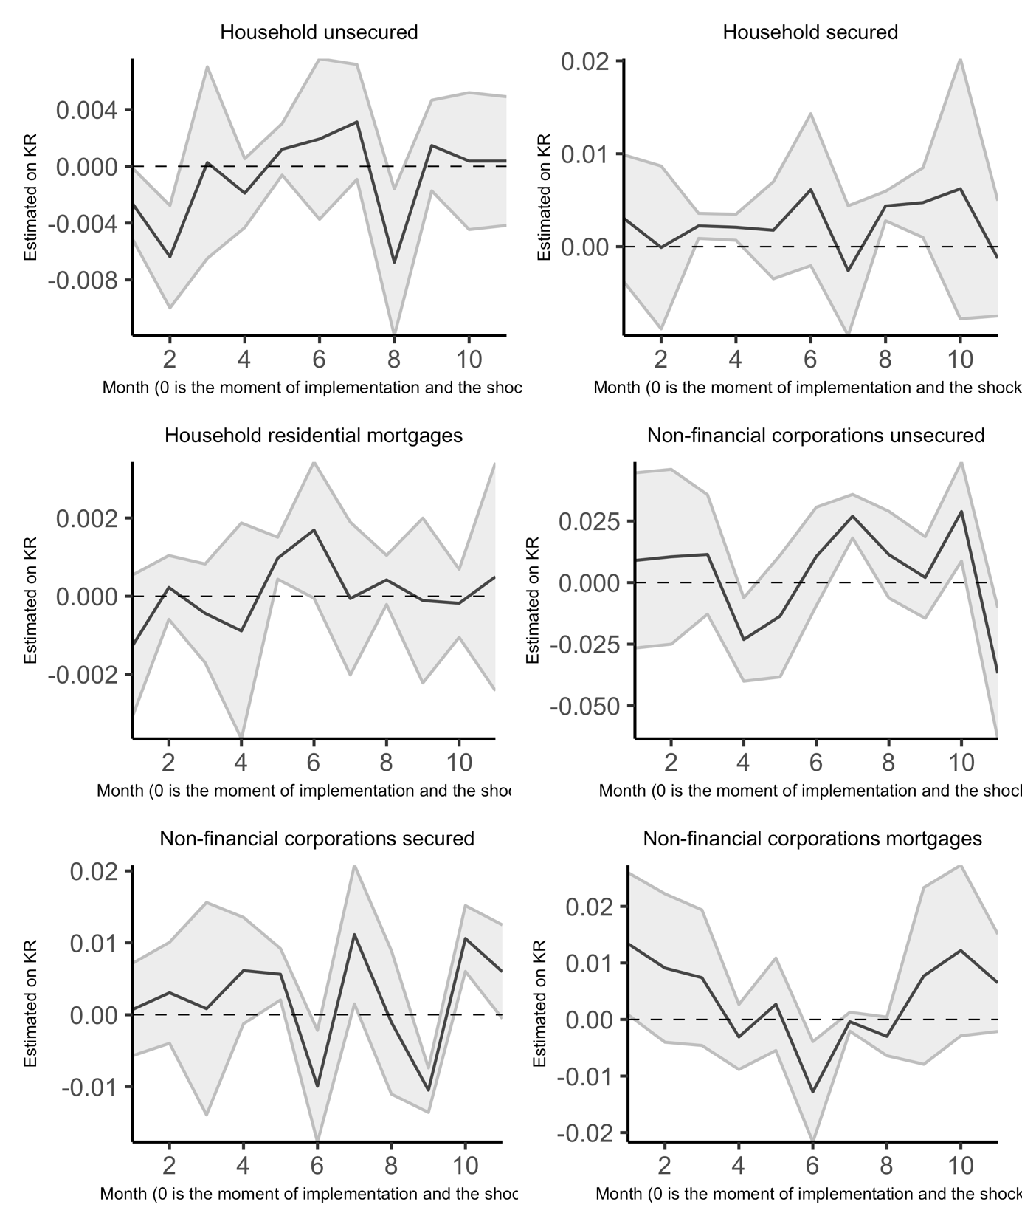**Figure 3: Impulse responses via local projections of lending () to a shock in capital requirements ()**

# 6 Conclusion

This paper has investigated the impact of the increased minimum bank capital requirements on banks in South Africa introduces in the transition to the more stringent Basel III capital regime. From our detailed review of the literature, highlighting the substantial challenges estimating causal impacts of changes in capital requirements on the supply of lending, we chose an empirical specification based that employed by on Fang et al. (2020) for Peru. Their specification avoids the shortcoming of many other studies of the impact of changing capital requirements on bank lending, where the changes to minimum capital may be a response to higher perceived loan portfolio risk, so reported estimates of the impact of capital on lending are confounded by changes in credit risk. This is achieved by focusing on larger pre-announced increases in minimum capital requirements and excluding smaller changes that can be attributed to changes in portfolio risk.

While our set up is similar to Fang et al. (2020), we find very much weaker evidence of an impact of capital requirements on the supply of bank lending. We investigate the impact three categories of lending for both household and corporate borrowers. Only in the case of secured credit for non-financial corporations do we obtain a statistically significant and economically sensible coefficient estimates and the coefficient is relatively small (a 1% increase in capital requirement reducing lending by 0.63% (with no bank controls) and 0.89% (with bank level controls). For the relatively short data period of our estimation, from 2013 to 2019, we find no significant impact of the level of capital or of capital buffers over the minimum requirement on the level of lending. Exploring alternative dynamic estimation similarly yields little evidence of any

There are several reasons why the impact of higher minimum capital requirements introduced in South African under Basel III may be small. Most obviously, in our estimation period, the large South African banks have operated with large capital buffers and facing only a remote risk of falling short of capital; minimum equity capital may simply not be a constrain on their portfolio decisions. Furthermore, the Basel III changes in minimum capital were announced well in advance, with a longer period to adjust than was the case for the changes in Peru investigated by Fang et al. (2020). may be the case. Clearly further investigation is warranted, but it appears than the South African authorities have introduced the higher capital requirements of Basel III in a sensible way with little or no impact on bank lending, at least for the four large banks in our sample. Lastly, other research can take the idea of using lending rates as demand proxies forward by including other bank funding specific factors, and comparing this approach to other approaches such as using sector lending data.

## Appendix A: Theoretical review

This appendix is a review of the theory of bank capital and bank lending. It identifies several key points relevant to the empirical investigation:

### A.1 A conceptual framework drawing on corporate finance and banking theory

A large literature examines the impact of regulatory capital requirements on bank credit supply. To draw a consistent picture of the findings from this literature, it is helpful to review the mechanisms linking bank capital to credit supply, employing a conceptual framework based on standard corporate finance theory. In the complete markets setting of Modigliani and Miller (1958) the mix of equity and debt funding, and therefore also capital regulation, is irrelevant; but there are several reasons why the mix of funding will in practice impact on lending and other business decisions. Some of these reasons apply broadly to banks, non-bank financial intermediaries and non-financial corporates, while others are bank specific.

The focus of what follows is on how capital structure and capital regulation impacts on the on the overall costs of bank funding and hence on the supply of bank credit; and in empirical estimation on distinguishing credit supply from the demand for credit:

Where represents the cost of bank funding and represents factors such as income and expected income growth that affect the demand for bank credit.

The composition of the bank balance sheet can be represented, schematically as:

distinguishing different categories of loans (, ), security investments (), core deposits (), wholesale funding () and equity capital ().

Bank capitalisation , the buffer of capital above the minimum regulatory capital requirement, funding liquidity and the liquidity buffer above minimum regulatory liquidity ratio (the NSF ) can then be represented (with risk weights , ) as

For capital structure and capital regulation to have any impact at all: equity must be more expensive than debt funding, whether in the form of core deposits or in other forms of debt. If there are then also costs associated with renegotiation of debt obligations or any corporate restructuring following a default on debt obligations, then the expected frequency and hence costs of debt default costs will rise as leverage is increased

This implies that there is a desired target or market driven level of capitalisation at which the marginal benefit of higher capitalisation (reducing the expected frequency and hence cost of debt default) equals the marginal higher funding cost (the higher costs of equity relative to debt). Raising new capital and returning new capital to shareholders is, for tax and signalling reasons, costly. This further implies that capital cannot always be maintained at the desired level (). Similarly changing the composition of debt finance, for example attracting additional core deposits, is also costly, so while we can expect a desired level of liquidity actual liquidity can depart from desired liquidity ().

A further factors determining the desired capital buffer is the ‘charter’ or ‘franchise’ value of an institution and the extent to which a bank can alter the balance of risk and returns on its balance sheet without outside stakeholders especially debt holders and regulators being aware. Charter value loosely represents the value of claims on future earnings lost in the event of a reorganisation following a breach of minimum levels of capital and liquidity that triggers a resolution and reorganisation of the liabilities with equity holders potentially losing their claims.

The observation of risk taking is critical because of the possibility of ‘moral hazard’, that if an institution can take high risks without a corresponding increase in the costs of debt finance then it may be induced to take deliberately high levels of risks that create value through ‘risk shifting’ i.e. transferring the costs of risk and resulting resolution from equity to debt holders. One insight from theoretical modelling of bank capital buffers [for example; Milne and Whalley (2002)] is that there are two potential qualitatively different solutions: one with a relatively high charter value, in which incentives for risk shifting are low and are dominated by the desire to preserve charter value, so there is as a result an ‘internal optimum’ with a high level of desired capital and relatively low levels of risk taking; the other with low charter value in which incentives for risk shifting dominate those for preservation of charter value, leading to a ‘corner solution’ in which capital buffers are maintained at very low levels and there are high levels of risk taking.

The overall cost of funding () will depend on the market rate of interest (), the departure between actual and desired bank capital and actual and desired liquidity:

The consequence is that, according to this basic theory, the impact of a change in capital on the supply of lending is non-linear. The function falls to a minimum when , at which point ( reflecting bank specific operational and other costs); but when capital falls or liquidity fall short of the target levels (, ) then costs of funding rise and .

The extent to which a shortfall of capital or liquidity increases the cost of funding will depend on the probability of a breach of minimum levels of either capital or liquidity. When shortfall from desired levels are relatively small then the probability of a breach and impact on funding costs of a change in capital or liquidity are also relatively small; but when shortfall from desired levels are large small then the probability of a breach and impact on funding costs of any change in capital or liquidity are relatively large. Thus is non-linear and we can expect the first and second derivatives to be signed as follows:

These higher cost of funding () arise because of the costs of altering capital and liquidity towards their desired or target levels. Again there is a trade-off: the further capital or liquidity falls below target the more balance sheet resources are allocated to increasing capital and liquidity and the less to the funding of lending. We can expect the expected rate of accumulation of capital and liquidity to be (approximately) proportional to the marginal costs of reduced capital or liquidity

and (employing a somewhat loose notation) the dynamic evolution of funding costs, capital and liquidity can be summarised as:

How are the costs of funding impacted by minimum capital and liquidity requirements and . It is necessary to distinguish long term and short term impacts.

Over the longer run the desired target of market level of capitalisation is increased but with a relatively small impacts on the cost of funding and supply of credit. Standard corporate finance theory suggests, somewhat against the intuitions of banking practitioners, that regulatory capital and liquidity requirements will have only a minor long-run impact on the cost of bank funding and the supply of bank credit [for elaboration see; Hellwig and Admati (2014)]. This is because the marginal benefits of higher leverage resulting from the separation of ownership and control and resulting agency costs of equity depend upon the threat of intervention and consequent loss of managerial control. A breach of regulatory minimum capital or liquidity requirements triggers intervention and disciplines management in much the same way as a default on debt payments. Therefore, the relevant leverage is that based on the buffer of excess capital or liquidity ratios over and above the required regulatory minima.

If these buffers are independent of the regulatory minima i.e. if the desired capital and desired liquidity are determined by a fixed buffers and independently of the regulatory minima and so:

Over the longer run, once balance sheets have fully adjusted, and increase in line with and and there is no impact on funding costs or credit supply.

This is not the entire story, even over the long run. Taxation may increase costs of debt relative to equity and hence raise minimum funding costs . On the other hand – in the event of a breach of minimum capital or liquidity requirements – resolution may be less costly, avoiding for example protracted legal disputes. In this case the desired buffers and minimum funding costs could be reduced by higher capital requirements. Thus both the sign and magnitude of the long run impact of minimum capital requirements is an empirical question. Since many factors will influence funding costs over the long run it is these are likely to be difficult to quantify empirically.

What the theory indicates is that these effects can be expected to be , second order impacts, relatively smaller than the short-term impact of changing capital requirements arising when either leads to a fall in the buffers of capital and liquidity over their long run levels.

For example, following an increase in regulatory capital requirements or an unexpectedly high level of loan loss provisions, a bank may find that its buffer of excess capital is below the level it desires and, in response, increase the margins on lending rates and limit lending capital is rebuilt.

### A.2 Implications for empirical modelling

This discussion of corporate finance and banking theory, leads to an insight that can be exploited empirically in estimating the impact of regulatory requirements on the supply of lending. The short term impact of an increase in required bank capital or liquidity will be quantitatively very similar to a decline in actual capital or liquidity resulting from earnings of balance sheet shocks. is useful because it allows conclusions about the impact of higher capital and liquidity requirements on the costs and volume of loans, from to be based on observations of the impact shocks to observed bank capital and liquidity due to market, credit or other risks.

All this indicates that empirical modelling of the impact on regulatory requirements on capital and liquidity on the supply of bank lending is a challenging research task. This task is made even more challenging by variation in bank risk appetite and in the perception of loan and other asset risks, both cross-sectionally between banks and in time series cyclically. Some banks may have relatively conservative business models seeking to avoid substantial portfolio tail risk and doing all they can to avoid potential financial distress; other business models may involve much greater risk taking. These differences affect both desired capital buffers and the response to discrepancy between desired and actual capital. In periods of credit expansion banks across the industry may perceive risks of loss as relatively small and be unconcerned about low levels of capital buffers; while episodes of credit loss and especially systemic financial crisis may trigger perceptions of high levels risk and more cautious behaviour.

Relatively high costs of bank equity arise for several reasons, most obviously agency costs arising from the separation of ownership and control in larger institutions: senior management are disciplined by greater leverage and the resulting greater impact of their decisions on returns to equity holders. Debt may also have relatively lower cost than equity for institutional reasons, for example tax deductibility or access to strong retail deposit franchises, reasons that are especially important in an environment of high nominal interest rates. Arguably short-term wholesale debt funding is also relatively less costly than long term debt or equity because it exerts a stronger disciplinary role on management (Calomiris and Kahn, 1991).

Costs of debt renegotiation and corporate restructuring are more difficult to characterise, arising for several reasons including: (i) the legal and administrative costs of valuing assets and assessing liabilities; (ii) the loss of value associated with finding purchasers of illiquid assets in ‘fire sales’ and (iii) resolution of conflicting claims in debt renegotiation or corporate restructuring; (iv) the loss of value from not continuing future value creating operations or selling them at a discount, what is referred to in the banking context as loss of ‘charter’ or ‘franchise’ value. Offsetting these costs, creating value for equity and debt holders, is the possibility of ‘risk shifting’ i.e. transferring losses onto third parties, through government backed bailouts or deposit insurance arrangements.

A further factor magnifying the costs and reducing the supply of bank credit is opacity. As long as bank portfolio risks are understood by outside investors, then the marginal benefit of higher capitalisation depends only on the resulting reduction in the expected costs of debt renegotiation and corporate restructuring, not on the allocation of return on loans or other investment assets between debt and equity holders. Equity holders, in response to higher capitalisation, will require higher returns to compensate them for greater risk exposure, but this is offset by lower required returns for debt holders leaving overall funding costs unchanged. Opacity of risk imposes further costs on all outside investors, holders of both debt and of equity. If risks are better understood by bank management and employees than by outside investors, then these costs can in theory be reduced through sharing equity with employees and management i.e. giving them ‘skin in the game’, but the extent of such reductions are unclear. Opacity of risk is also a major reason why low income households and small businesses are excluded from access to credit. This implies that financial technologies can potentially reduce the opacity of bank credit portfolios and improve the supply of bank credit.

## Appendix B: Data

**Table B.1: Data Sources**

|  | Description | Availability | Source |
| --- | --- | --- | --- |
| BA900 | Banking sector balance sheet data at a bank level | Public data | South African Reserve Bank |
| BA930 | Banking sector lending rates at a bank level | Aggregated data is public.  Bank specific data is private | South African Reserve Bank |
| Controls | Banking sector performance data at a bank level | Aggregated data is public.  Bank specific data is private | Prudential Authority |
| GDP | Nominal gross domestic product in a calendar year | Public data | Statistics South Africa |
| BA700 | Regulatory capital buffer requirements | Aggregated data is public.  Bank specific data is private | Prudential Authority |
| Repo rate | Policy rate of the South African Reserve Bank | Public data | South African Reserve Bank |

**Table B.2: Data Description**

| Variable Description | Data Description | Measure | Cross-section | Sample | Frequency |
| --- | --- | --- | --- | --- | --- |
| Loans by lending category and bank | BA 900 data on bank level credit at a monthly frequency.  We have summarised to six lending categories:  Household secured credit, Household unsecured credit, Household residential mortgages,  Non-financial sector secured credit, Non-financial sector unsecured credit,  and Non-financial sector mortgages as explain in Appendix B. | Rand | Nedbank, First National Bank, Standard Bank, Absa | January 2008 to November 2022 | Monthly |
| Lending rate by lending category and bank | BA 930 data on bank level lending rates at a monthly frequency.  Lending rates are defined as the weighted average rate  by lending category. These were also summarised into the  same six lending categories as shown in Appendix B. | Percent | Nedbank, First National Bank, Standard Bank, Absa | January 2012 to June 2022 | Monthly |
| Capital buffer | Aggregate amount of qualifying capital and  reserve funds less minimum required capital and reserve funds. | Percent | Nedbank, First National Bank, Standard Bank, Absa | January 2008 to September 2020 | Monthly |
| Capital requirement | Basel III required level of capital as a percentage of risk-weighted assets | Percent | Nedbank, First National Bank, Standard Bank, Absa | January 2008 to September 2020 | Monthly |
| Repo rate | South African Reserve Bank policy rate | Percent | NA | January 2008 to February 2021 | Monthly |
| GDP | Nominal gross domestic product. | Rand | NA | March 2008 to March 2022 | Quarterly |
| Bank level performance metrics | The following are bank performance metrics are include in the data:  total assets, gross loan advances, retained earnings, net interest income (12 months), level one high-quality liquid assets required to be held,  average daily amount of level one high-quality liquid assets held up to  fourteenth business day of the month following the month to which this return relates,  aggregate risk weighted exposure, return on equity, return on assets,  total capital adequacy ratio, and leverage ratio. | Rand and percent | Nedbank, First National Bank, Standard Bank, Absa | January 2008 to September 2022 | Monthly |

## 

## B.3 Lending rates (BA930s)

**Figure B.1: Lending Rates**

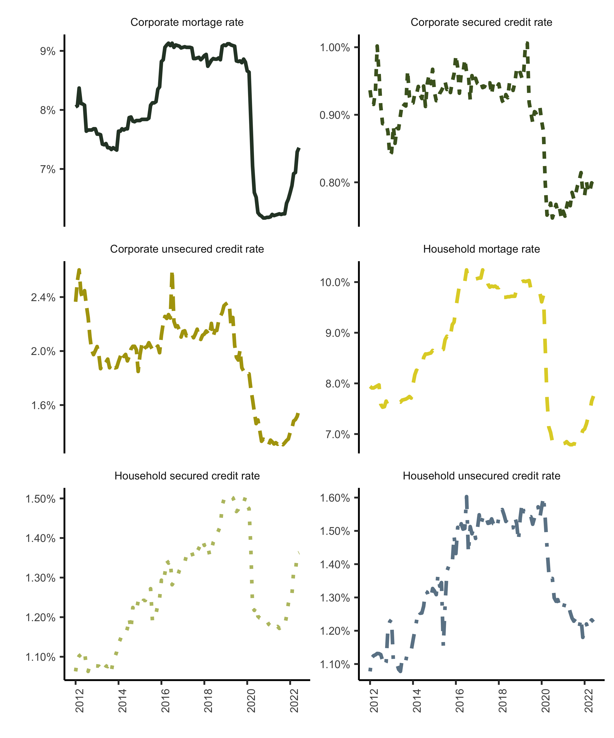

Source: South African Reserve Bank (2022)

## B.4 Aggregation schema

The following tabulation is derived from the BA900s is the balance sheet return loan data (lines 103 to 277) and gives relative magnitudes by financial corporate sector, non-financial corporate sector and household sector. This is the most granular data provided. The missing item numbers are all aggregations of these numbers.

**Table B.3: Aggregation schema**

| BA 900 Categories | Item Number | Sector | Aggregation Key |
| --- | --- | --- | --- |
| Installment sales | 141 | Financial corporate sector | - |
|  | 142 | Non-financial corporate sector | a |
|  | 143 | Household sector | c |
|  | 144 | Other | a |
| Leasing transactions | 146 | Financial corporate sector | - |
|  | 147 | Non-financial corporate sector | a |
|  | 148 | Household sector | c |
|  | 149 | Other | a |
| Farm mortgages | 152 | Non-financial corporate sector | b |
|  | 153 | Household sector | b |
|  | 154 | Other | b |
| Residential mortgages | 156 | Non-financial corporate sector | b |
|  | 157 | Household sector | d |
|  | 158 | Other | b |
| Commercial and other mortgages | 160 | Public financial corporates | - |
|  | 161 | Public non-financial corporates | - |
|  | 162 | Private financial corporate | - |
|  | 163 | Private non-financial corporates | b |
|  | 164 | Household sector | b |
|  | 165 | Other | b |
| Credit cards | 167 | Financial corporate sector | - |
|  | 168 | Non-financial corporate sector | a |
|  | 169 | Household sector | c |
|  | 170 | Other | c |
| Overdrafts | 178 | Public sector (includes public corporations and local government) | - |
|  | 181 | Financial corporate sector | - |
|  | 182 | Non-financial corporate sector | a |
|  | 183 | Unincorporated business enterprises | e |
|  | 184 | Other Household sector | c |
|  | 185 | Non-profit organisations serving households | c |
| Factoring debtors | 187 |  | a |
| Other loans and advances | 189 | Financial corporate sector | - |
|  | 190 | Non-financial corporate sector | b |
|  | 191 | Unincorporated business enterprises | e |
|  | 192 | Other Household sector | - |
|  | 193 | Non-profit organisations serving households | - |
|  |  |  |  |

The following aggregation scheme which results in six categories was followed based on Table B.3, with unincorporated enterprise credit as part of household unsecured lending.

1. Non-financial corporate sector secured credit: Items 142 + 147
2. Non-financial corporate sector unsecured credit: Items 168 + 182 + 187+ 190
3. Non-financial corporate sector mortgages (commercial and other mortgage advances): Items 152 + 153 + 154 + 156 + 158 + 163 + 164 + 165
4. Household sector secured credit: Items 143 + 148
5. Household sector unsecured credit: Items 169 + 184 + 185 + 192 + 193 + 183 + 191 (note includes unincorporated business enterprise credit last two items)
6. Household sector residential mortgages: Item 157

The loans quantities from the BA900s are then linked to the lending rate data from the BA930s to create six lending rate categories the schema on Table B.4.

**Table B.4: Weighting schema**

| Sector | BA 930 Categories | Item Number | Weighting Key |
| --- | --- | --- | --- |
| Corporate sector | Overdrafts | 48.000 | b |
|  | Instalment sale agreements flexible rate | 49.000 | a |
|  | Instalment sale fixed rate | 50.000 | - |
|  | Leasing transactions flexible rate | 51.000 | a |
|  | Leasing transactions fixed rate | 52.000 | - |
|  | Mortgage advances flexible rate | 53.000 | c |
|  | Mortgage advances fixed rate | 54.000 | - |
|  | Credit cards | 55.000 | b |
|  | Other | 56.000 | b |
| Household sector | Overdrafts | 58.000 | e |
|  | Instalment sale agreements flexible rate | 59.000 | d |
|  | Instalment sale fixed rate | 60.000 | - |
|  | Leasing transactions flexible rate | 61.000 | d |
|  | Leasing transactions fixed rate | 62.000 | - |
|  | Mortgage advances flexible rate | 63.000 | f |
|  | Mortgage advances fixed rate | 64.000 | - |
|  | Credit cards | 65.000 | e |
|  | Other | 66.000 | e |

The six categories, therefore, are as follows:

1. Non-financial corporate sector secured credit rate: Weighted average of items 49 + 51
2. Non-financial corporate sector unsecured credit rate: Weighted average items 48 + 55 + 56
3. Non-financial corporate sector mortgage rate: Item 53
4. Household sector secured credit rate: Weighted average of items 59 + 61
5. Household sector unsecured credit rate: Weighted average of items 58 + 65 + 66
6. Household sector residential mortgages: Item 63

## Appendix C: Three-month loans growth results

**Table C.1: Household 3-month loan growth results**

|  | (1) | (2) | (3) | (4) | (5) |
| --- | --- | --- | --- | --- | --- |
| **Household secured credit model** |  |  |  |  |  |
|  | -0.0094*** | -0.0096*** | -0.0061* | -0.0076*** | -0.0041 |
|  | (0.0030) | (0.0028) | (0.0034) | (0.0017) | (0.0033) |
|  |  | -0.1009 | -0.0152 | -0.0315 | 0.0502 |
|  |  | (0.2955) | (0.3348) | (0.1753) | (0.2039) |
|  |  |  | -0.0001 |  | 0.0004 |
|  |  |  | (0.0089) |  | (0.0100) |
|  |  |  |  | 0.3273 | 0.1973 |
|  |  |  |  | (4.5698) | (4.3791) |
|  |  |  |  | -0.2378 | -0.2302 |
|  |  |  |  | (0.3768) | (0.3664) |
|  |  |  |  | -0.0274 | -0.0267 |
|  |  |  |  | (0.0224) | (0.0236) |
| Num.Obs. | 372 | 372 | 369 | 368 | 365 |
| Adj.R squared | 0.410 | 0.409 | 0.407 | 0.459 | 0.458 |
| Test of equality (p-value) | 0.00 | 0.00 | 0.16 | 0.00 | 0.26 |
| **Household unsecured credit model** |  |  |  |  |  |
|  | -0.0099* | -0.0100* | -0.0032 | -0.0096** | -0.0039 |
|  | (0.0051) | (0.0052) | (0.0056) | (0.0041) | (0.0063) |
|  |  | -0.0522 | 0.1648 | -0.0816 | 0.0769 |
|  |  | (0.1246) | (0.1561) | (0.1393) | (0.2098) |
|  |  |  | -0.0213* |  | -0.0194* |
|  |  |  | (0.0122) |  | (0.0103) |
|  |  |  |  | 2.7782 | 2.0878 |
|  |  |  |  | (4.1950) | (3.9166) |
|  |  |  |  | -0.2210 | -0.1838 |
|  |  |  |  | (0.3458) | (0.3276) |
|  |  |  |  | -0.0153 | -0.0089 |
|  |  |  |  | (0.0233) | (0.0241) |
| Num.Obs. | 372 | 372 | 368 | 368 | 364 |
| Adj.R squared | 0.565 | 0.564 | 0.580 | 0.561 | 0.573 |
| Test of equality (p-value) | 0.05 | 0.03 | 0.07 | 0.02 | 0.22 |
| **Household mortgage credit model** |  |  |  |  |  |
|  | -0.0020 | -0.0020 | -0.0018 | -0.0028* | -0.0026** |
|  | (0.0014) | (0.0015) | (0.0013) | (0.0015) | (0.0013) |
|  |  | 0.0055 | 0.0100 | 0.0200 | 0.0265 |
|  |  | (0.0498) | (0.0513) | (0.0624) | (0.0713) |
|  |  |  | -0.0016 |  | -0.0015 |
|  |  |  | (0.0014) |  | (0.0013) |
|  |  |  |  | 1.6274*** | 1.6751*** |
|  |  |  |  | (0.6151) | (0.5685) |
|  |  |  |  | -0.1130** | -0.1170** |
|  |  |  |  | (0.0526) | (0.0468) |
|  |  |  |  | 0.0085 | 0.0084 |
|  |  |  |  | (0.0072) | (0.0071) |
| Num.Obs. | 372 | 372 | 368 | 368 | 364 |
| Adj.R squared | 0.694 | 0.693 | 0.693 | 0.736 | 0.736 |
| Test of equality (p-value) | 0.19 | 0.24 | 0.19 | 0.02 | 0.01 |
| Note: Household sector results with longer 3-month loan growth period. The dependant variables in loan growth at bank level at a monthly frequency, calculated as the log difference at t and t -3. All control variables are defined in Table 3. Standard errors are clustered at a bank level. All equations include both bank and monthly effects. A test for equality p-value of < 0.1 is significant. | | | | | |

**Table C.2: Non-financial corporations 3-month loan growth results**

|  | (1) | (2) | (3) | (4) | (5) |
| --- | --- | --- | --- | --- | --- |
| **Non-financial corporations secured credit model** |  |  |  |  |  |
|  | -0.0113** | -0.0114** | -0.0013 | -0.0084 | -0.0016 |
|  | (0.0054) | (0.0055) | (0.0087) | (0.0059) | (0.0073) |
|  |  | -0.0510 | 0.2170 | 0.1645 | 0.3136 |
|  |  | (0.1622) | (0.2017) | (0.1943) | (0.1922) |
|  |  |  | -0.0126* |  | 0.0064 |
|  |  |  | (0.0070) |  | (0.0063) |
|  |  |  |  | 1.1543 | 0.9446 |
|  |  |  |  | (3.5779) | (3.8589) |
|  |  |  |  | -0.1414 | -0.1250 |
|  |  |  |  | (0.2154) | (0.2376) |
|  |  |  |  | -0.0496*** | -0.0493*** |
|  |  |  |  | (0.0047) | (0.0042) |
| Num.Obs. | 372 | 372 | 368 | 368 | 364 |
| Adj.R squared | 0.410 | 0.409 | 0.407 | 0.459 | 0.458 |
| Test of equality (p-value) | 0.00 | 0.00 | 0.16 | 0.00 | 0.26 |
| **Non-financial corporations unsecured credit model** |  |  |  |  |  |
|  | 0.0313*** | 0.0303*** | 0.0157** | 0.0408*** | 0.0190** |
|  | (0.0016) | (0.0018) | (0.0066) | (0.0074) | (0.0093) |
|  |  | -0.4822 | -0.7947 | -0.3665 | -0.8247 |
|  |  | (0.6430) | (0.6690) | (0.4773) | (0.5198) |
|  |  |  | -0.0134 |  | 0.0046 |
|  |  |  | (0.0082) |  | (0.0092) |
|  |  |  |  | 3.0914 | 4.0843 |
|  |  |  |  | (4.8279) | (4.1092) |
|  |  |  |  | -0.1259 | -0.1892 |
|  |  |  |  | (0.2285) | (0.1804) |
|  |  |  |  | -0.0738*** | -0.0807*** |
|  |  |  |  | (0.0216) | (0.0223) |
| Num.Obs. | 372 | 372 | 364 | 368 | 360 |
| Adj.R squared | 0.565 | 0.564 | 0.580 | 0.561 | 0.573 |
| Test of equality (p-value) | 0.05 | 0.03 | 0.07 | 0.02 | 0.22 |
| **Non-financial corporations mortgage credit model** |  |  |  |  |  |
|  | 0.0027 | 0.0025 | 0.0015 | 0.0006 | 0.0006 |
|  | (0.0113) | (0.0117) | (0.0112) | (0.0113) | (0.0108) |
|  |  | -0.1010 | -0.1307 | -0.1236 | -0.1566 |
|  |  | (0.3393) | (0.3985) | (0.3404) | (0.3608) |
|  |  |  | 0.0037 |  | -0.0007 |
|  |  |  | (0.0057) |  | (0.0034) |
|  |  |  |  | 4.1386 | 3.6179 |
|  |  |  |  | (6.2007) | (6.0718) |
|  |  |  |  | -0.2979 | -0.2599 |
|  |  |  |  | (0.4071) | (0.4075) |
|  |  |  |  | 0.0225 | 0.0234 |
|  |  |  |  | (0.0251) | (0.0244) |
| Num.Obs. | 372 | 372 | 368 | 368 | 364 |
| Adj.R squared | 0.694 | 0.693 | 0.693 | 0.736 | 0.736 |
| Test of equality (p-value) | 0.19 | 0.24 | 0.19 | 0.02 | 0.01 |
| Note: Non-financial corporations results with 3-month loan growth period. The dependant variables in loan growth at bank level at a monthly frequency, calculated as the log difference at t and t -3. All control variables are defined in Table 3. Standard errors are clustered at a bank level. All equations include both bank and monthly effects. A test for equality p-value of < 0.1 is significant. | | | | | |

# References

Aiyar, S., Calomiris, C. W., & Wieladek, T. (2014a). Does macro‐prudential regulation leak? Evidence from a UK policy experiment. Journal of Money, Credit and Banking, 46(s1), 181–214.

Aiyar, S., Calomiris, C. W., Hooley, J., Korniyenko, Y. and Wieladek, T. (2014b). ‘The international transmission of bank capital requirements: Evidence from the UK’. *Journal of Financial Economics*. Elsevier, 113 (3), pp. 368–382.

Aiyar, S., Calomiris, C. W. and Wieladek, T. (2016). ‘How does credit supply respond to monetary policy and bank minimum capital requirements?’ *European Economic Review*. Elsevier, 82, pp. 142–165.

Ateba, B. B. and Prinsloo, J. J. (2019). ‘Strategic management for electricity supply sustainability in south africa’. *Utilities Policy*. Elsevier, 56, pp. 92–103.

Berger, A. N. and Udell, G. F. (1994). ‘Lines of credit and relationship lending in small firm finance’. *Jerome Levy Economics Institute Working Paper*, (113).

Berrospide, J. M. and Edge, R. M. (2010). ‘The effects of bank capital on lending: What do we know, and what does it mean?’ CAMA Working Paper Series 26/2010.

Calomiris, C. W. and Kahn, C. M. (1991). ‘The role of demandable debt in structuring optimal banking arrangements’. *The American Economic Review*. JSTOR, pp. 497–513.

Calomiris, Charles W. and Berry Wilson. (2004). “Bank Capital and Portfolio Management: The 1930s ‘Capital Crunch’ and the Scramble to Shed Risk.” Journal of Business 77(3).

De Jonghe, O., Dewachter, H. and Ongena, S. (2020). ‘Bank capital (requirements) and credit supply: Evidence from pillar 2 decisions’. *Journal of Corporate Finance*. Elsevier, 60, p. 101518.

Fang, X., Jutrsa, D., Peria, S. M., Presbitero, A. F. and Ratnovski, L. (2020). ‘Bank capital requirements and lending in emerging markets: The role of bank characteristics and economic conditions’. *Journal of Banking & Finance*. Elsevier, p. 105806.

Folly, K. A. (2021). ‘Competition and restructuring of the south african electricity market’. in *Local electricity markets*. Elsevier, pp. 355–366.

Fraisse, H., Lé, M. and Thesmar, D. (2020). ‘The real effects of bank capital requirements’. *Management Science*. INFORMS, 66 (1), pp. 5–23.

Francis, W. B. and Osborne, M. (2012). ‘Capital requirements and bank behavior in the UK: Are there lessons for international capital standards?’ *Journal of Banking & Finance*. Elsevier, 36 (3), pp. 803–816.

Gambacorta, L. and Mistrulli, P. E. (2004). ‘Does bank capital affect lending behavior?’ *Journal of Financial intermediation*. Elsevier, 13 (4), pp. 436–457.

Hancock, D. and Wilcox, J. A. (1994). ‘Bank capital and the credit crunch: The roles of risk-weighted and unweighted capital regulations’. *Real Estate Economics*. Wiley Online Library, 22 (1), pp. 59–94.

Hellwig, M. and Admati, A. (2014). *The bankers’ new clothes: What’s wrong with banking and what to do about it-updated edition*. Princeton University Press.

Houston, J., James, C. and Marcus, D. (1997). ‘Capital market frictions and the role of internal capital markets in banking’. *Journal of financial Economics*. Elsevier, 46 (2), pp. 135–164.

Imbierowicz, B., Kragh, J. and Rangvid, J. (2018). ‘Time-varying capital requirements and disclosure rules: Effects on capitalization and lending decisions’. *Journal of Money, Credit and Banking*. Wiley Online Library, 50 (4), pp. 573–602.

Jiménez, G., Ongena, S., Peydró, J.-L. and Saurina, J. (2017). ‘Macroprudential policy, countercyclical bank capital buffers, and credit supply: Evidence from the spanish dynamic provisioning experiments’. *Journal of Political Economy*. University of Chicago Press Chicago, IL, 125 (6), pp. 2126–2177.

Jordà, Ò. (2005). ‘Estimation and inference of impulse responses by local projections’. *American* economic review. American Economic Association, 95 (1), pp. 161–182.

Khwaja, A. I., & Mian, A. (2008). Tracing the impact of bank liquidity shocks: Evidence from an emerging market. American Economic Review, 98(4), 1413–1442.

Milne, A. and Whalley, A. (2002). ‘Bank capital regulation and incentives for risk-taking (SSRN scholarly paper no. ID 299319). Rochester, NY: Social science research network’.

Modigliani, F. and Miller, M. H. (1958). ‘The cost of capital, corporate finance and the theory of investment’. *American Economic Review*, 48, pp. 261–97.

Nier, E. and Zicchino, L. (2005). ‘Bank weakness and bank loan supply’. *Bank of England Financial Stability Review (December)*, pp. 85–93.

Nowak, M. (2005). ‘The first ten years after apartheid: An overview of the south african economy’. *Post-Apartheid South Africa: The First Ten Years. Washington, DC: International Monetary Fund*, pp. 1–10.

Nowak, M. M. and Ricci, M. L. A. (2006). ‘Post-apartheid south africa: The first ten years’. International Monetary Fund.

Peek, J. and Rosengren, E. S. (1997). ‘The international transmission of financial shocks: The case of Japan’. *The American Economic Review*. JSTOR, pp. 495–505.

Pillay, N. and Makrelov, K. (2023). ‘Capital buffers and lending in south africa (forthcoming)’. South African Reserve Bank.

Van den Heuvel, S. J. (2008). ‘The welfare cost of bank capital requirements’. *Journal of Monetary Economics*. Elsevier, 55 (2), pp. 298–320.

1. . South African Reserve Bank, Pretoria, South Africa; Email: xolani.sibande@resbank.co.za. We thank the reviewers for their invaluable comments.
2. Loughborough Business School, Loughborough University, Loughborough, United Kingdom; Email: A.K.L.Milne@lboro.ac.uk
3. This literature is part of broader literature on credit supply shocks and bank lending, see Degryse et al. (2019) for a more comprehensive review.
4. Macroeconomic data, except where otherwise specified, is from the IMF data mapper <https://www.imf.org/external/datamapper/profile/ZAF>
5. Nowak (2005); Nowak and Ricci (2006)
6. See the 2010 IMF Article IV consultation, Sept 2010, highlighting South Africa’s strong economic performance since the mid-1990s.
7. <https://www.resbank.co.za/en/home/what-we-do/Prudentialregulation/sa-registered-banks-and-representative-offices>, January 2022; these consisted of 13 branches of foreign banks, 4 foreign controlled commercial bank subsidiaries, 14 locally controlled commercial banks and 3 mutual banks.
8. As of April, 2020, these were (% of banking sector assets): Standard Bank of South Africa (24.1%), First Rand (20.4%), ABSA (19.8%), Nedbank (17.0%) and Investec (7.8%); the next largest bank is Capitec (2%).
9. IMF financial soundness indicators
10. Annexure A of Directive 5 of 2013 by the Office of the Register of Banks